**PDF (Easy)**

**Our analysts managed to get a hold of a document that we believe has a flag on it. Can you recover it?**

**What is the name of the program that exported this PDF file?**

**What PDF version is this file?**

* Right-click on pdf.
* Click “Properties.
* Answer: Adobe Photoshop.
* Answer: 1.7

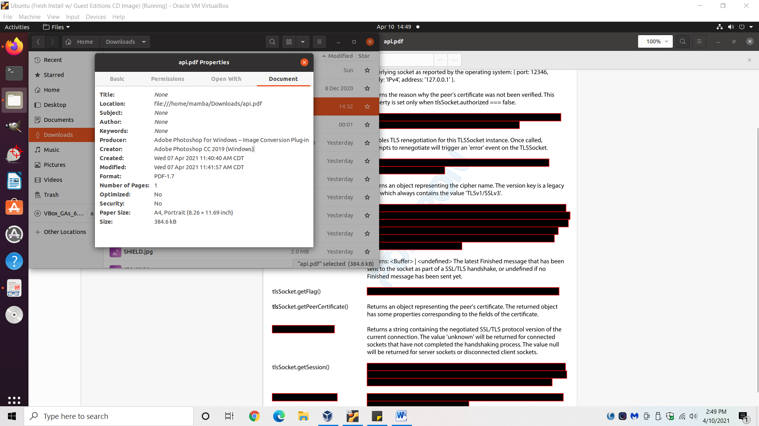

**What software was used to redact the file and inserted a watermark?**

* Notice the blue watermark running through the center of the page.
  + Some of the watermark is blocked, but looks like “PDF[*blocked*]RON.”
  + *Look at the image below to see the watermark.
* Google “PDFRON.”
  + First company that pops up is PDFTron.
* Answer: PDFTron

**What is the flag?**

* Although the file is redacted, by highlighting the text, you can see through the redaction.
* Search through the document for the flag hidden under the redaction.
* Note: you can also use the search bar to search for strings, including those visibly hidden by the redaction.

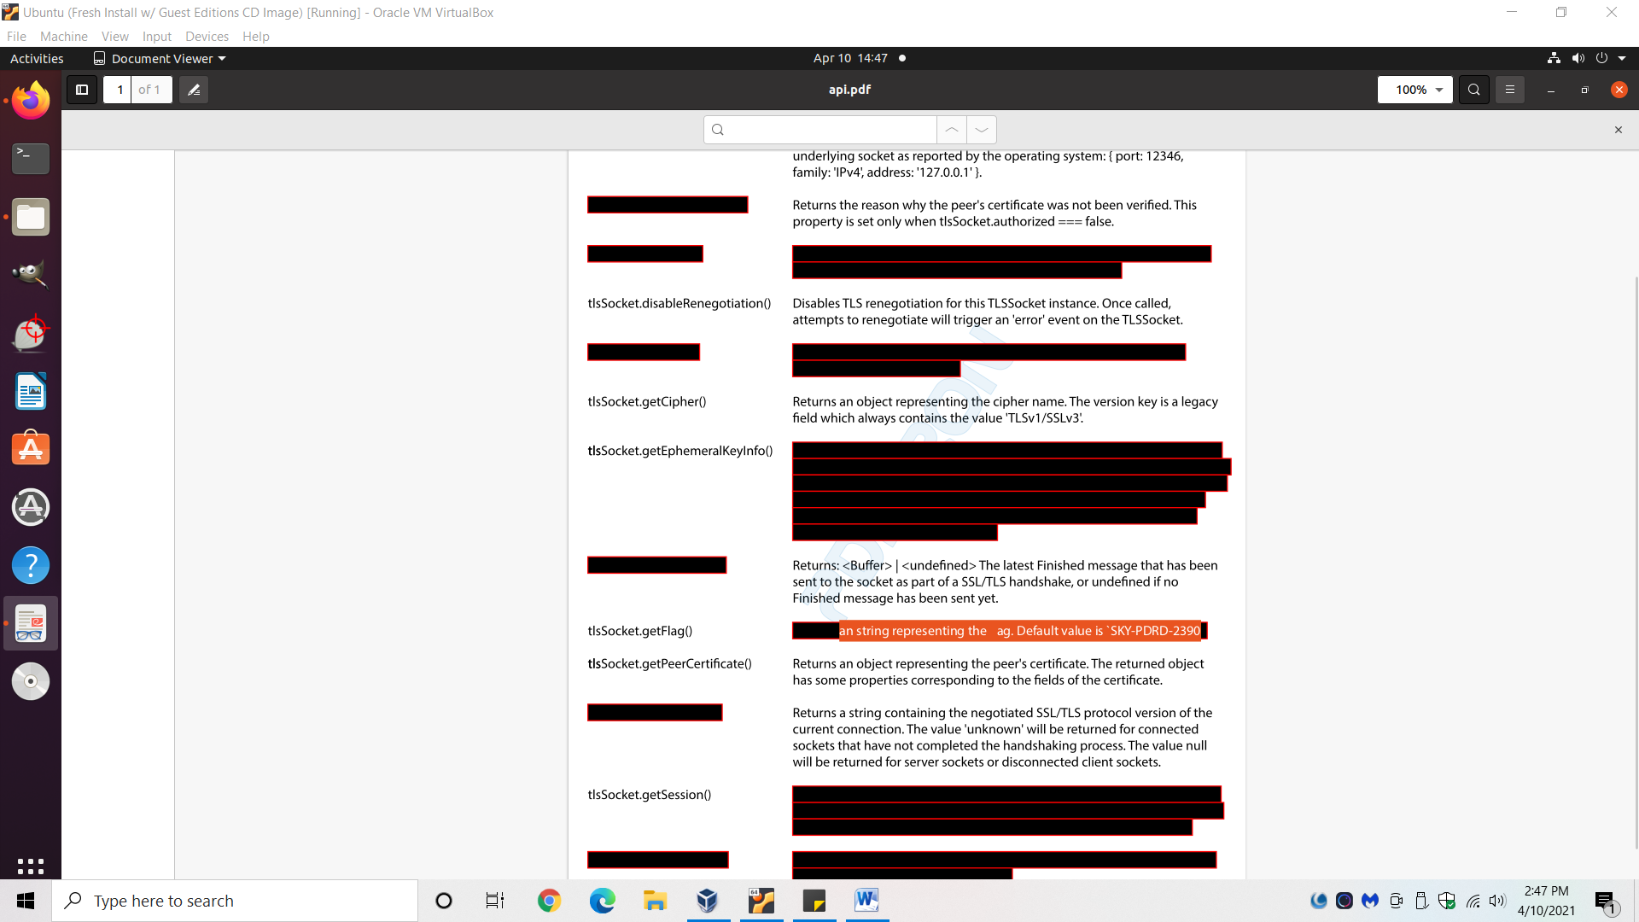

* Answer: SKY - PDRD- 2390